JIANG JING QIU

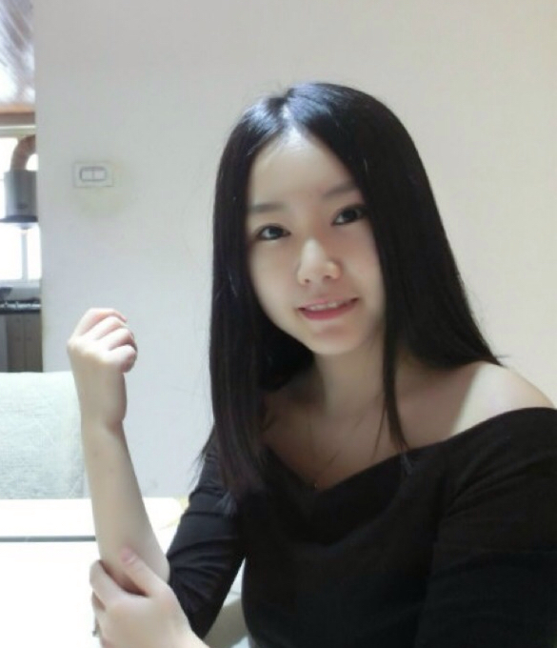

Address: No 9, SS22/9,

Damansara Jaya,

Petaling Jaya

47400

Mobile: 01112527779

EMAIL: [jqoons@gmail.com](mailto:jqoons@gmail.com)

CAREER OBJECTIVES

Aspire to obtain a challenging position that I can fully utilize my knowledge and skills

EXPERIENCE

**WONGKOK Waitress** 2013 Jun-Sep

* Take order from customers
* Check with customers to ensure that they are enjoying their meals and take action to correct any problems
* Clean tables or counters after patrons have finished dining.

**PURPLE CANE Sales** 2012 Jun-Aug

* Selling and promoting products
* Serve Customer with Kungfu Tea
* Preparing and Cooking Tea Egg

EDUCATION

BACHERLOR OF ARTS BUSINESS MANAGEMENT & MARKETING

KDU COLLEGE, DAMANSARA JAYA

PETALING JAYA, SELANGOR JUN 2013